Case Study Analysis – Apple Inc.

**INTERNSHIP TASK** -**2**

**CodeAlpha**

Prepared by : **REEMA – M**

Date : 2.10.2025

# INTRODUCTION

Apple Inc., founded in 1976 by Steve Jobs, Steve Wozniak, and Ronald Wayne, is one of the most successful and iconic technology companies in the world. Headquartered in Cupertino, California, Apple has revolutionized the personal computing, smartphone, and consumer electronics industries through innovation, design excellence, and a focus on seamless user experience.  
  
The company’s mission, “to bring the best user experience to its customers through its innovative hardware, software, and services,” reflects its commitment to delivering products that combine technology, design, and lifestyle integration. Apple’s product portfolio includes the iPhone, iPad, Mac, Apple Watch, AirPods, and Apple TV, alongside software services such as iOS, macOS, iCloud, Apple Music, Apple Pay, and the App Store.  
  
This case study explores Apple’s business model, marketing strategies, the reasons behind its success, and key lessons that can be learned for modern businesses. Apple’s marketing approach is renowned for creating brand loyalty, premium perception, and emotional engagement with consumers worldwide.

# APPLE’S BUSINESS MODEL

Apple’s business model is based on a combination of hardware sales, software ecosystem, and recurring service revenue. Its strategy focuses on innovation, premium pricing, and ecosystem integration.  
  
**Ecosystem Integration:**Apple creates a seamless ecosystem where devices, software, and services are interconnected:  
- iPhone connects with Mac, iPad, Apple Watch, and AirPods.  
- iCloud enables cross-device synchronization and storage.  
- Services like Apple Music, Apple TV+, and Apple Pay integrate with hardware, enhancing user dependency on the ecosystem.  
  
**Premium Product Strategy:**- Apple positions itself as a premium brand, offering high-quality, well-designed products.  
- Pricing strategy reflects innovation, design, and brand value rather than competing solely on cost.  
- This allows high profit margins and reinforces exclusivity.  
  
**Revenue Streams:**- Hardware Sales – iPhone, Mac, iPad, Apple Watch, AirPods.  
- Services – App Store, iCloud, Apple Music, Apple TV+, Apple Pay.  
- Software – Operating systems and productivity tools like iWork.  
  
**Brand Differentiation:**- Sleek, minimalist design.  
- Consistent innovation and high-quality materials.  
- User-friendly interface and intuitive software.  
- Emotional branding that connects with lifestyle and status.

# APPLE’S MARKETING STRATEGIES

Apple’s marketing approach is widely studied and admired for its simplicity, consistency, and emotional appeal.

**Product Launch Events:**

* Apple’s product launches are global events covered extensively by media.
* Keynote presentations focus on storytelling, product features, and innovation.
* Launch events create anticipation, hype, and viral attention for each product.

**Minimal Traditional Advertising:**

* Apple uses selective advertising, focusing on high-quality visuals and messaging.
* Campaigns highlight design, lifestyle integration, and simplicity.
* Example: “Think Different” campaign emphasized innovation and emotional connection.

**Premium Branding and Emotional Marketing:**

* Apple markets its products as status symbols and lifestyle enhancements.
* Advertising appeals to emotions, aspiration, and identity, making consumers feel part of an elite user community.

**Retail Experience:**

* Apple Stores are designed for immersive experiences rather than just sales.
* Hands-on interaction with devices encourages engagement, discovery, and brand loyalty.
* Genius Bar and workshops strengthen customer relationships.

**Digital and Social Media Presence:**

* Apple maintains a strong presence across digital platforms, including its website, YouTube, and social media.
* Product videos, tutorials, and stories are crafted to emphasize simplicity and innovation.

**Scarcity and Exclusivity:**

* New products often have initially limited availability, creating excitement and desire.
* Pre-orders and waiting lists generate hype and media attention.

**Ecosystem Marketing:**

* Apple promotes the interconnectedness of its devices, encouraging customers to buy multiple products to maximize experience.
* Example: iPhone + Apple Watch + AirPods + Mac integration creates loyalty and increases repeat purchases.

# APPLE’S STRATEGY WORKED

**Strong Brand Loyalty:**

* Apple customers are highly loyal, often purchasing multiple products across the ecosystem.
* Emotional branding and superior user experience ensure repeat purchases.

**Product Excellence:**

* Apple products are known for quality, design, reliability, and innovation.
* High customer satisfaction leads to positive word-of-mouth marketing.

**Strategic Marketing and Storytelling:**

* Product launches, advertisements, and events tell a consistent story about innovation, lifestyle, and simplicity.
* Storytelling engages consumers emotionally, differentiating Apple from competitors.
* Ecosystem Lock-In:
* Interconnected devices and services create high switching costs, making it convenient for users to stay within Apple’s ecosystem.

**Scarcity and Hype Generation:**

* Pre-orders, waiting periods, and exclusive releases create anticipation and social proof.
* Media coverage amplifies excitement and positions Apple as an aspirational brand.

**Leadership and Vision:**

* Steve Jobs’ focus on innovation, design, and user experience established Apple’s brand ethos.
* Tim Cook’s operational efficiency and supply chain mastery support global scalability.

# WHY APPLE’S STRATEGY WORKED

**Strong Brand Loyalty:**

* Apple customers are highly loyal, often purchasing multiple products across the ecosystem.
* Emotional branding and superior user experience ensure repeat purchases.

**Product Excellence:**

* Apple products are known for quality, design, reliability, and innovation.
* High customer satisfaction leads to positive word-of-mouth marketing.

**Strategic Marketing and Storytelling:**

* Product launches, advertisements, and events tell a consistent story about innovation, lifestyle, and simplicity.
* Storytelling engages consumers emotionally, differentiating Apple from competitors.

**Ecosystem Lock-In:**

* Interconnected devices and services create high switching costs, making it convenient for users to stay within Apple’s ecosystem.

**Scarcity and Hype Generation:**

* Pre-orders, waiting periods, and exclusive releases create anticipation and social proof.
* Media coverage amplifies excitement and positions Apple as an aspirational brand.

**Leadership and Vision:**

* Steve Jobs’ focus on innovation, design, and user experience established Apple’s brand ethos.
* Tim Cook’s operational efficiency and supply chain mastery support global scalability.

# LESSONS LEARNED

**Simplicity and Consistency:**

* Clear, consistent messaging across all platforms strengthens brand identity.

**Emotional Connection Matters:**

* Marketing that appeals to aspiration, lifestyle, and identity creates deeper consumer loyalty.

**Ecosystem Strategy is Powerful:**

* Integrating products and services encourages repeated purchases and long-term engagement.

**Product as Marketing:**

* Exceptional products generate organic marketing through word-of-mouth and media coverage.

**Launch Events as Marketing Tools:**

* Major events can replace traditional advertising by creating anticipation, media buzz, and viral attention.

**Premium Pricing Adds Value:**

* Positioning products as exclusive and premium strengthens brand perception and profitability.

# CONCLUSION

Apple’s marketing strategy demonstrates that success is not just about advertising—it’s about designing exceptional products, creating emotional appeal, and building an interconnected ecosystem.

Through innovative product design, experiential retail, strategic launches, and lifestyle marketing, Apple has cultivated a loyal global customer base. Its approach shows that consistency, storytelling, premium branding, and customer experience are critical to long-term business success.

The lessons from Apple are valuable for any company aiming to create iconic products, generate brand loyalty, and compete in technology-driven markets. By combining product excellence with strategic marketing, Apple continues to maintain its leadership position and inspire businesses worldwide.

# DIAGRAMS & CHARTS

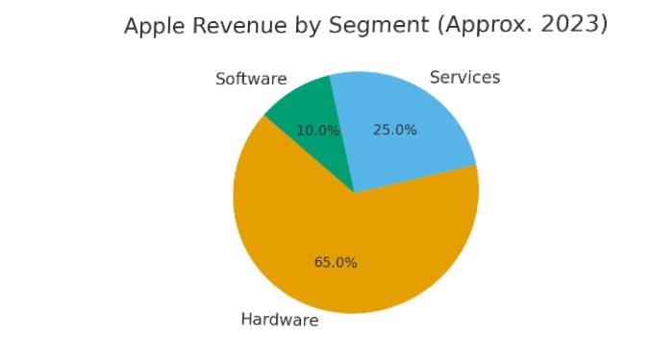**Figure 1: Apple Revenue by Segment (Approx.**

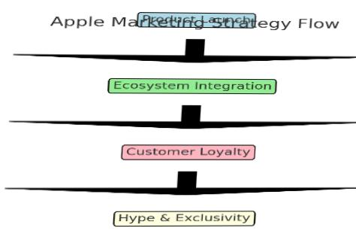

**Figure 2: Apple Marketing Strategy Flow**

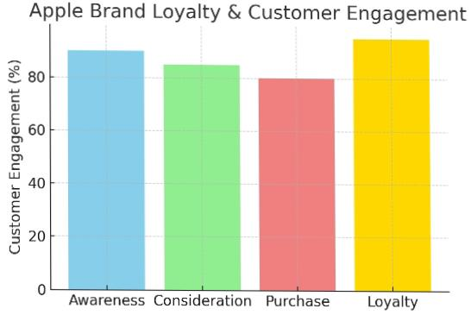

**Figure 3: Apple Brand Loyalty & Customer Engagement**